СЦЕНАРИЙ ШКОЛЬНОГО СПЕКТАКЛЯ
“THE BREMEN TOWN MUSICIANS”

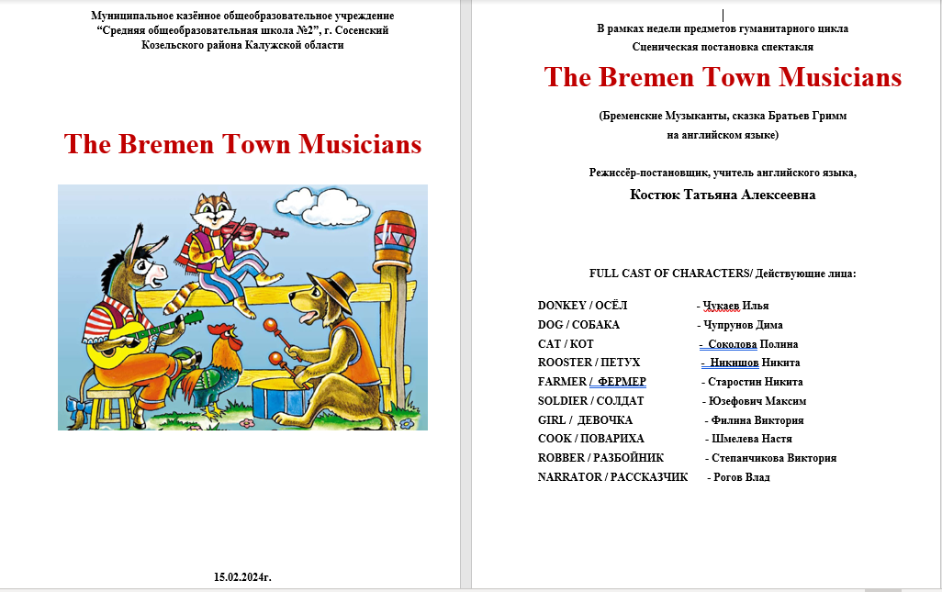

FULL CAST OF CHARACTERS: NARRATOR, DONKEY, DOG, CAT, FARMER, SOLDIER, BOY, ROOSTER, OLD WOMAN COOK, ROBBER

Декорации:
1.Скамейка (посередине сцены)
2.Домик (слева от сцены)
3. Перед домиком сбоку стол и стул для вора
3.Деревья, ёлки, трава, цветы (справа от сцены)

15.02.2024

ACT 1
Narrator, farmer, donkey
In a forest
Играет музыка /начало/
NARRATOR: Once upon a time there lived a donkey, a dog, a cat and a rooster.
Do you want to hear the story of these poor animals? If yes, clap your hands
The donkey lives on a farm. Some years ago he was strong and hard-working and the farmer was pleased with him. But now he is old and weak.
Играет грустная музыка
FARMER: Well, this is really bad. I need a strong animal who can work for me. If the donkey can’t carry things, I don’t need him.
Get out of here! Can’t work no more, so get out! And never let me see you here again! You’re worthless old Donkey!
Играет сказочная музыка
NARRATOR:
He doesn’t want to go away. But what can he do? Nobody wants him now, because he is old and can’t work anymore.
Играет грустная песня/ослик начинает плакать/

DONKEY: (уходит от фермера и поет песню) ЗВУЧИТ ПЕСНЯ
I’m
I’m the old donkey
I’m the deserted old donkey
I worked hard for my master
But now he’s trying to desert me!

Farmer (и все за сценой поют):
Run away, oh run far away
Run away, oh run far away
Then where should I go?
Where should I head to?
How can I live leaving the old farm?
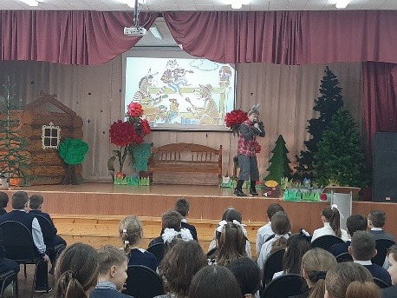

DONKEY: Clip-clop, Clip-clop! Hee-haw! Hee-haw! Clip-clop, Clip-clop! (ЗВУКИ)
Играет грустная песня /ослик садится на скамейку и продолжает плакать/
NARRATOR: But the donkey knows that in the town of Bremen there are lots of street musicians, and if you play good music, you live well.
DONKEY: I like the guitar. I think I will play it very well. I think I’ll go to Bremen to become a musician. (ЗВУКИ-Go to Bremen!)
NARRATOR: The donkey hasn’t got a guitar, but it doesn’t matter. He is going to Bremen. (ЗВУКИ Clip-clop, Clip-clop!)

Act II
Soldier, dog
Играет суетливая, печальная музыка /как у воров/
SOLDIER: And stay away, you flea-bitten mongrel! Your pups are better watchdogs than you! You’re worthless cur! Get out of here!
(собака начинает плакать и поет песню) ПЕСНЯ

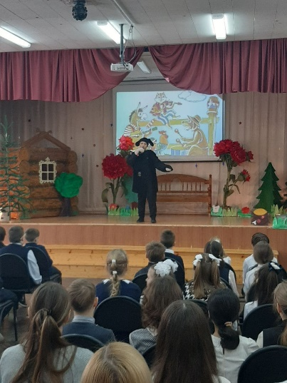
DOG:
Song
I have lost all my claws
And I lost my one last tooth.
I worked hard for my dear master
And now he is selling me off.

You say an old dog is useless.
Now you say I’m useless.
You say an old dog is useless.
Now you say I’m useless.

I have lost all my claws
And I lost my one last tooth.
I worked hard for my dear master
And now he is selling me off.

Leaving the farm where should I head to?
Where should I go?
Leaving the farm where should I head to?
Where should I go?

Leaving the farm where should I head to?
Where should I go?
Leaving the farm where should I head to?
Where should I go?
Играет грустная музыка /собака садится на скамейку/

ACT III
Narrator, dog, donkey
Играет грустная музыка
DOG: Arf! How! Grr! (сидит возле дороги)
DONKEY: Why are you so sad, old boy?
DOG: My master wants to drive me away because now I am too old to guard the house!
DONKEY: Don’t worry, old boy! I’m going to Bremen to become a musician. I’m going to play the guitar. I’ve heard that Bremen Town is a friendly place. Come with me!
DOG : Wow! I’ll go with you to Bremen! I will play the drum.

Играет сказочная музыка

NARRATOR: So the donkey and the dog are friends now and they are going to Bremen.

DONKEY: Clip-clop, Clip-clop! Hee-haw! Hee-haw! Clip-clop, Clip-clop!
DOG : WOOF-WOOF!

ACT IV
Girl, cat
Играет суетливая, печальная музыка /как у воров/
Girl: Mummy doesn’t want you to be here no more! You’re nasty and dirty and smelly and mum is tired of feeding you! Get out of here or I will drive you away! (кот убегает)
CAT: Meow!

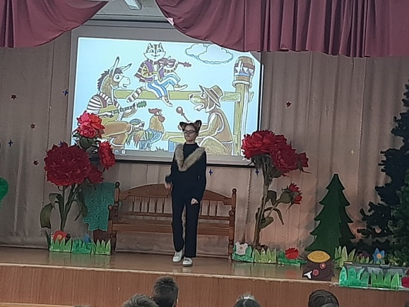

Играет грустная музыка/кот начинает плакать/
Поет песню

Song
I’m a cat, an old cat.
My silky fur is all gone.
I’m a cat, an old cat.
My body is so chubby.

I worked hard to catch mice,
Just to make my master glad.
And now she’s trying to sell me off,
Saying old cats are useless.

Leaving the farm where should I go?
To where should I head to?
Leaving the farm where should I go?
What should I do afterward?

Leaving the farm where should I go?
To where should I head to?
Leaving the farm where should I go?
What should I do afterward?

Играет грустная музыка/кот продолжает плакать и садится на лавку/

ACT V
Narrator, dog, donkey, cat

Играет грустная музыка
CAT: Meow! (сидит возле дороги)
DONKEY AND DOG: Why are you so sad, old cat?
CAT: My master wants to drive me away because now I am too old to catch the mice.
DONKEY: Don’t worry, old cat! We’re going to Bremen to become musicians. I’m going to play the guitar, and the dog is going to play the drum! Come with us!
CAT: Wow! I’ll go with you to Bremen! I will play the violin!

Играет сказочная музыка
NARRATOR: So the donkey, the dog and the cat are friends now and they are going to Bremen.

Уходят со сцены и каждый издает свои звуки.

ACT VI
Rooster, old woman cook

Играет суетливая, печальная музыка /как у воров/
Внезапно петух кукарекает, расправляет крылья и убегает.

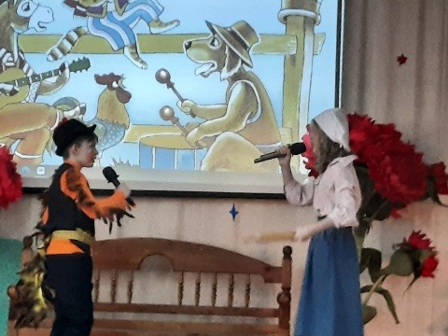

ROOSTER: Cock-a-doodle-doo!
OLD WOMAN COOK: Get back here, dinner! I can’t wait to eat you up! Goodness knows you’re worthless for anything else!
ROOSTER: Cock-a-doodle-doo!
OLD WOMAN COOK: I’ve got the answer, dearie little rooster, and it’s called a kettle, a frying pan or a boiling pot -like it or not!!!

Играет грустная музыка/петух начинает плакать и петь/
ROOSTER: Cock-a-doodle-doo! (убегает)
Поет песню
I’m rooster, an old rooster
I can’t see anymore nor make a sound
I’m rooster, an old rooster
I can’t see anymore nor make a sound
I always sang for my dear master
And now he’s trying to throw me away
I always sang for my dear master
And now he’s saying I’m useless
Leaving the farm where should I go?
Leaving the farm where should I go?
Leaving the farm what should I do?
Leaving the farm what should I do?

Играет грустная музыка/петух продолжает плакать и садится на лавку/

ACT VII
Rooster, donkey, dog, cat, narrator

Играет грустная музыка
ROOSTER: Cock-a-doodle-doo! (on the road)
DONKEY: Hee-haw!
DOG: Grr!Grrr! Woof-woof!
CAT: Meow
DONKEY, DOG, CAT: Why are you so sad, Mr. Rooster?
ROOSTER: My master wants to drive me away because now I’m old and sometimes forget to crow in the morning.
DONKEY: Don’t worry, Mr. Rooster. We’re going to Bremen to become musicians. I’m going to play the guitar, the dog is going to play the drum, and the cat is going to play the violin. Come with us!
ROOSTER: Wow! I’ll go with you to Bremen! I will sing!

Играет сказочная музыка
NARRATOR: So the donkey, the dog, the cat and the rooster are friends now and they are going to Bremen.
DONKEY: Clip-clop! Hee-haw!
DOG: Grr! Grrr! Woof-woof!
CAT: Meow
ROOSTER: Cock-a-doodle-doo! (on the road)

ACT VIII
Narrator, rooster, cat, dog, donkey, robber
Играет сказочная музыка

NARRATOR: The road to Bremen is very long. Moreover, it’s getting dark.

That’s why the donkey, the dog and the cat are going to sleep in the forest and the rooster is going to sleep by an old tree.
(идут главные персонажи, ложатся под дерево)-звуки сна

Через несколько секунд появляются музыка /УТРО/
Персонажи потягиваются, просыпаются, петух первый встает и кукарекает
Все еще играет музыка /УТРО/

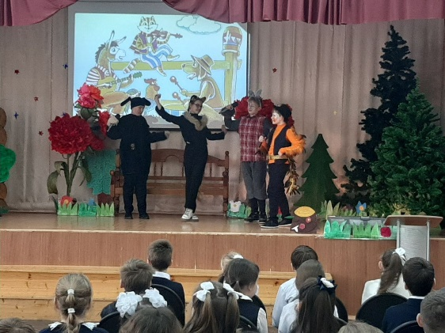
ROOSTER: Cock-a-doodle-doo!
ROOSTER: I see something. There is a house in the forest, and there is light inside. Do you think they have comfortable beds and tasty food?
DONKEY: I think they have. Let’s go there.
DOG: There is a man in the room. He is mean and cruel. He looks like a robber.
CAT: There is some bread, some butter, some cheese, nuts, a cake and sweet drinks on the table. There are also several comfortable beds in the room.
DONKEY: Wow! We must get inside and eat all that lovely food and sleep in those comfortable beds.
CAT: But what can we do?
DOG: Hmmm. Usually, if you play music, people give you money and food, right?
ROOSTER: Right! Well, let’s give them a show! I am sure they will give us some food and let us spend the night in their warm house.

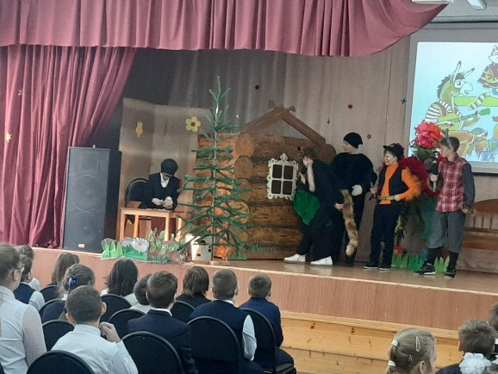

ACT IX
Narrator, rooster, cat, dog, donkey, robber
Играет сказочная музыка
NARRATOR: Look! (выжидает паузу)
The dog is jumping on the donkey’s back, the cat is jumping on the dog’s back and the rooster is flying onto the cat’s back.

В это время возле домика сидит вор (за столом считает деньги)

DONKEY: Ready? One, two, three!
И начинают вместе издавать свои звуки
CAT: MEOW! DOG: WOOF-WOOF! DONKEY: HEE-HAW!
ROOSTER: COCK-A-DOODLE-DOO! (и так 5 раз)

ОБЬЯСНЕНИЕ! (the donkey “is playing the guitar”, the dog “is playing the drum”, the cat “is playing the violin” and the rooster “ is singing”. But really the donkey is braying, the dog is barking , the cat is meowing and the rooster is crowing.)

Вор подпрыгивает, сгребает деньги в мешок и убегает со словами
ROBBER: It’s a monster! Help! (убегают)

DONKEY, DOG, CAT, ROOSTER: Hooray!
DONKEY: Our first show went very well! Now we can stay in this house for the night.
Hooray (заходят в дом)
Издают звуки сна в домике

ACT X

Chieftain, donkey, dog, cat, rooster
Играет музыка /вор/

CHIEFTAIN…
Stop. It can’t be a monster. I don’t believe they exist. This is my house. I will go back and drive it away.

(Вор возвращается обратно к своему дому и заходит в дом)
Как только вор подходит к коту, кот мяукает и царапает лицо, потом собака лает и кусает за ногу, осел упирается и ударяет вора в живот, а петух кукарекает и взлетает на голову вора) это все происходит в самом домике, а зрители этого не видят, но только слышат, как мерзко животные издают свои звуки)

CAT: MEOW!
(screams the cat and scratches the robber’s face)
DOG: WOOF-WOOF!
(barks the dog and bites the robber’s leg )

DONKEY: HEE-HAW!
(brays the donkey and kicks the robber in the stomach)
ROOSTER: COCK-A-DOODLE-DOO! (craws the rooster and flies onto the chieftain’s head)
Продолжает играть музыка /вор/

Вор выбегает из домика и кричит:
CHIEFTAIN: It’s a monster! It’s a monster! I will never come back to this forest again! (и убегает).

Животные снова засыпают/издают звуки сна/

ACT XI

Narrator, donkey, dog, cat, rooster

Звучит музыка /утро/
NARRATOR:
In the morning four friends are having a talk.

Выходят из домика, просыпаются
DOG: Well, I don’t think we need to go to Bremen now.
CAT: I don’t know what to do. It is such a long way, and we have no musical instruments.
ROOSTER: I don’t need a musical instrument. I can sing.
DONKEY: Maybe we don’t need to go to Bremen. We have a nice house here, and we can probably find food in the forest.

В то время, как автор рассказывает следующие слова,
ослик, собака, кот и петух рассматривают дом, шушукаются по поводу, что нужно изменить в доме.

Звучит сказочная музыка

NARRATOR: And it was true. They are happy in their house, they can find nuts and fruit in the forest to eat.

Ослик, собака, кот и петух подходят к середины сцены и берутся за руки

NARRATOR : So, the musicians of Bremen don’t want to go to Bremen now as they are really best friends now.

Ослик, собака, кот и петух начинают петь песню, а потом выходят все остальные персонажи сказки и поют вместе с ними.
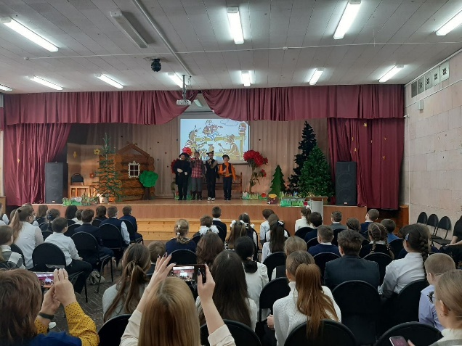

Поют песню
Song
We are the town musicians of Bremen
We love to march and sing together. /маршируют/
La-la-la-la-la la-la-la la-la-la la-la la
La-la-la-la-la la-la-la go to Bremen.

Выходят остальные персонажи сказки и подпевают им.

We are the town musicians of Bremen
We love to march and sing together. /маршируют/
La-la-la-la-la la-la-la la-la-la la-la la
La-la-la-la-la la-la-la go to Bremen.

THE END

