**г. ИРКУТСК**

**АДМИНИСТРАЦИЯ**

**КОМИТЕТ ПО СОЦИАЛЬНОЙ ПОЛИТИКЕ И КУЛЬТУРЕ**

**ДЕПАРТАМЕНТ ОБРАЗОВАНИЯ**

**МУНИЦИПАЛЬНОЕ БЮДЖЕТНОЕ**

**ОБЩЕОБРАЗОВАТЕЛЬНОЕ УЧРЕЖДЕНИЕ Г. ИРКУТСКА**

**СРЕДНЯЯ ОБЩЕОБРАЗОВАТЕЛЬНАЯ ШКОЛА № 71**

|  |
| --- |
| 664005 - Иркутск, ул. Маяковского, 14  тел/факс – 38-89-11. Е – mail: school71.irk@yandex.ru |

**ПЛАН-КОНСПЕКТ УРОКА АНГЛИЙСКОГО ЯЗЫКА**

**ПО ТЕМЕ «ЗДОРОВЫЙ ОБРАЗ ЖИЗНИ»**

**9 КЛАСС**

**УЧИТЕЛЬ ПЕРВОЙ КВАЛИФИКАЦИОННОЙ КАТЕГОРИИ МИКОЛЮК ГАЛИНА АЛЕКСАНДРОВНА**

**ПЛАН-КОНСПЕКТ УРОКА АНГЛИЙСКОГО ЯЗЫКА**

**ДАТА:** _________

**ТЕМА:** повторение и обобщение материала по теме «Здоровый образ жизни»/ «Healthy way of life»

**КЛАСС:** 9

**УМК:** К. И. Кауфман, М. Ю. Кауфман «Счастливый английский.ру» / Happy English.ru

**ОБОРУДОВАНИЕ:** интерактивная доска, проектор, музыка для поведения релаксационной минутки, видео о продуктах питания, раздаточный материал (card 1: пословицы на английском языке, лист критерий оценивания для данного задания; карточки-опоры для развития речевой деятельности; card 2 (group 1),card 2 (group 2), card 2 (group 3) с заданиями по наречиям (much, many, a lot of, little, less, more), лист критерий оценивания для группового задания; карточки для составления схемы «Здоровый образ жизни».

**ЦЕЛЬ:** формировать иноязычно-коммуникативную компетентность учащихся посредством систематизации и обобщения лексико-грамматическогоматериала по теме «Здоровый образ жизни»/ «Healthy way of life».

**ЗАДАЧИ:**

**ОБРАЗОВАТЕЛЬНЫЕ:**

* Систематизировать изученный лексический и грамматический материал (наречия much, many, alotof, little, less, more) речевые обороты в устной речи и письме;
* формировать умение работать в мини-группах;
* формировать навыки неподготовленной речи;
* совершенствовать навыки говорения (монологической речи, умение высказываться логично и связно, продуктивно, умение анализировать и выражать свое мнение), чтения, письма.

**РАЗВИВАЮЩИЕ:**

* Развивать коммуникабельности и познавательной активности;
* развивать памяти, внимания, логики, цельности высказывания;
* повышать мотивации к изучению английского языка;
* развивать личностной активности (перенос учебного материала на личность учащихся);
* расширять кругозор учащихся, формировать коммуникативную компетенцию.

**ВОСПИТАТЕЛЬНЫЕ:**

* Формировать понятия ценности здоровья и воспитание физической культуры, здорового образа жизни;
* воспитывать отрицательное отношение к вредным для здоровья привычкам;
* воспитывать у учащихся правильное отношение к своему здоровью;
* познакомить со здоровым образом жизни, правильным питанием;
* дать установку на необходимость ведения здорового образа жизни, его преимуществах по отношению к вредным привычкам.

**ТИП УРОКА:**урок повторения и обобщения полученных знаний

**МЕТОДЫ РАБОТЫ:**

* методы по источникам знаний (словесный, наглядный, видеометод, практический методы);
* методы по характеру познавательной деятельности (объяснительно-иллюстративный, проблемный, частично-поисковый методы);
* методы по степени самостоятельности учащихся (учебная работа под руководством учителя и компьютерной программы на интерактивной доске, взаимообучение, самостоятельная работа обучающихся);
* методы контроля (устный и письменный контроль).

**ФОРМЫ РАБОТЫ:**

* Индивидуальная;
* групповая;
* фронтальная;
* коллективная.

**ПРИЁМЫ РАБОТЫ:**

* организация самостоятельной, групповой, коллективной, индивидуальной работ;
* привитие учащихся к учению, общеучебным умениям и навыкам;
* использование разнообразных методов обучения;
* использование на уроке интерактивной доски, раздаточного дидактического материала, наглядности;
* закрепление материала посредством выполнения устных и письменных упражнений;
* соблюдение единого орфографического режима;
* дифференциация и оригинальность домашнего задания.

**СОДЕРЖАНИЕ УРОКА**

1. **ОРГАНИЗАЦИОННЫЙ МОМЕНТ**
2. **ДОМАШНЕЕ ЗАДАНИЕ**
3. **ЦЕЛЕПОЛАГАНИЕ**
4. **РЕЧЕВАЯ ЗАРЯДКА**
5. **ВВЕДЕНИЕ В ТЕМУ УРОКА**
6. **ЗАКРЕПЛЕНИЕ ЛЕКСИЧЕСКИХ НАВЫКОВ**
7. **ЗАКРЕПЛЕНИЕ ГРАММАТИЧЕСКИХ НАВЫКОВ**
8. **РЕЛАКСАЦИОННАЯ ПАУЗА**
9. **РАЗВИТИЕ РЕЧЕВОЙ ДЕЯТЕЛЬНОСТИПО ТЕМЕ «ХОРОШИЕ И ПЛОХИЕ ПРИВЫЧКИ»**
10. **РЕФЛЕКСИЯ**
11. **ПОДВЕДЕНИЕ ИТОГОВ УРОКА**

**ХОД УРОКА**

1. **ОРГАНИЗАЦИОННЫЙМОМЕНТ**

Good morning, dear children! Today we are having our final lesson on the topic «Healthy Way of Life». You have been working on this theme a lot of time. I hope that you will show today your speaking, writing and reading skills and your understanding of the healthlifestyle.

1. **ДОМАШНЕЕ ЗАДАНИЕ**

Now open your grade books and write down the homework. When will be next lesson?

You have different types of homework. At home you should choose the best variant of your homework.

1. To write the summary of our theme «Healthy way of life».

During the lesson you may make notes in your copybooks and summarize it.

1. To make the presentation «Good and bad habits».

You should develop this idea in your presentation, give examples and to sum up everything.

1. To make the project «Healthy Living Guide» («Путеводитель по здоровому образу жизни»).

You may make it as a big poster, a handmade book. You should show everything that makes us healthy, give advises about good health eating, describe some exercises.

**3. ЦЕЛЕПОЛАГАНИЕ**

Open please your copybooks and write down the date, the theme of our lesson «Healthy way of life».What date is it today? What day of the week is today?

Today at the lesson we are goingto:

- repeat the vocabulary, expressions and proverbs related to our topic;

- remind about food groupsand their roles in our life;

-work with the health pyramid;

- discuss good and bad habits;

- do some exercises;

- work out the scheme «How to be healthy».

Today during our lesson we will use training handoutswhich are on the tables.Each of you has the round cards with notes about health way of life and when we will speak about it you may stand up and hang it on the black board.

1. **РЕЧЕВАЯЗАРЯДКА**

And now let’s continueour lesson with some interesting questions.

1) Do you eat dessert at every meal?

2) Do you eat front of the TV?

3) Did you eat any fruit yesterday?

4) Do you often skip breakfast?

5) What do you like to eat?

6) How often do you do physical activity?

7) Do you go to the fast food restaurant? How often?

8) Do you have soda rather than milk with your meal?

9) Do you snack all day long?

10) How often do you eat during a day?

11) What do you eat at school?

12) Do you like to eat vegetables?

Good, thank you very much for your honest answers. I see that each of you try to be healthy.

1. **ВВЕДЕНИЕ В ТЕМУ УРОКА**

Who can tell me what the name of our unit is? Yes, you are absolutely right! Good wealth is above wealth. And how we translate this proverb? (*варианты ответов учащихся:* Доброе здоровье дороже богатства. Здоровье дороже денег. Здоровье всего дороже. Здоровье дороже всякого богатства). And how do you understand this proverb?

Very well, and now you can see another proverbs or sayings about food and health. Take please CARD 1 (приложение 1).And this is your first task. Match the proverb and the translation first of all on the piece of paper, and then we will check it all together. If you have 6 points you will get 5. *(лист с критериями оценивания на доске).* I give you 2 minutes.

Now let’s check up. Who wants to go to the smart board? Say the proverb, and then give the Russian equivalent. Don’t forget to correct mistakes in your cards. *(учащийся на интерактивной доске соотносит поговорки и переводы, остальные проверяют в бланках).*

|  |  |
| --- | --- |
| 1.The purse of the patient protracts  the disease. | a) Здоровье дорожебогатства. |
| 2. Health is better than wealth. | b) Обжорство убивает быстрее,чем меч. |
| 3. Prevention is better than cure. | c) Голод-лучшая приправа. |
| 4. Hunger is the best sauce. | d) Мужчине столько лет,на сколько он себя чувствует,женщине-на сколько она выглядит. |
| 5. Gluttony kills more than the sword. | e) Болезнь легче предупредить,  чем лечить. |
| 6. A man is as old as he feels, a woman is as old as she looks. | f) Кошелёк клиента продлевает  болезнь. |

|  |  |  |  |  |  |
| --- | --- | --- | --- | --- | --- |
| **1** | **2** | **3** | **4** | **5** | **6** |
| **f** | **a** | **e** | **c** | **b** | **d** |

Who has got an excellent/ good/ satisfactory mark?You have done good job! I see you know every proverb.

**6. ЗАКРЕПЛЕНИЕЛЕКСИЧЕСКИХНАВЫКОВ**

Healthywayoflife.So, first of all it is our nutrition. Can you imagine our life without food? I think no. What is the main food’s purpose for us? Use the model. *(учащиеся говорят свои варианты ответа с карточками-опорами приложение 2)*

Food is known has three fundamental body needs: need for energy, need for growth, need to regulate different functions in our organism. Do you know the secrets of health and beauty? The secrets are in our food. The proverb says: «We are what we eat». You know that foods can be broken into groups - the food groups. Let’s remindthese groups. Who wants to go to the smart board and write down the food groups?

|  |  |  |  |  |
| --- | --- | --- | --- | --- |
| Bread/Cereal group/ Rise/ Pasta | Fruits and Vegetables group | Dairy group | Meat group | Fat/Sugar group |

Okay, thank you! I see you know food groups.

And what foods do belong to each group? Drag please the picture to the right column and say the food’s name. Use the model.

Приложение 3. *Учащиеся соотносят продукты в соответствии с группами еды, называя их вслух.*

|  |  |  |  |  |
| --- | --- | --- | --- | --- |
| **Bread/Cereal group** | **Fruit and Vegetables group** | **Dairy group** | **Meat/Beans/ Egg group** | **Fat/Sugar group** |
|  | | | | |
| cereals, spaghetti, noodles, pasta, bread, porridge, rise, pasta | apples, bananas, strawberry, potatoes, tomatoes, peppers, mushrooms | milk, cheese, yoghurt, butter, sour cream | ham, sausages,  eggs, peas, beans, pork, chicken | sweets, cake, chips, hamburger, soda, French fries, oils, chocolate |
| And now let’s watch a short video and you will know more useful information about products. After the watching you will get the task, that’s why be attentive!  *Просмотрфильма.*  Okay. Now let’s do the interesting task.You should match the productwith its functions.  *Работа с интерактивной доской.*  Well done! You are really were very attentive and have remembered a lot of information. | | | | |
| And now let’s look at this picture. What is the figure? (triangle or pyramid). And this pyramid is the symbol of the food pyramid. Let’s consider from the foundation to the top of this food pyramid.Are all parts of the food pyramid having the same size? No. Why? What the most important part in our health meal is? What should we eat and how many per cent does the every grouphave? | | | | |
| They give you energy by providing protein, iron and several B minerals. | They help you have good eyesight by providing VitaminsA and C, minerals.  They are very important for your health. | This group gives your  body an important  Mineral called calcium.  Your bones and teeth  need calcium  tobe healthy. | It helps you be strong and healthy. Many people eat fatless meat, because they know it gives much protein. | Weneeds a small amount of fat. Sugary foods usually don’t have many vitamins and have too much fat and calories in them**.** |

Excellent! You did a great job. You are now a healthy eater and know everything about food. Use the Food Pyramid as a guide for your balanced diet.

And how can we keep fit, be healthy and have an attractive appearance? What should we doto be healthy? Let’s look at pictures and name them.With the help of these physical activities we can burn calories alsoand lose weight. Let’s draw a conclusion. If we will eat properly, we will have good health.Very good!

1. **ЗАКРЕПЛЕНИЕГРАММАТИЧЕСКИХНАВЫКОВ**

Nowlet’srememberourgrammar – aboutsuchadverbsasmuch, many, little, alotof.When we use much (uncountable nouns), many (countable nouns), little (uncountable nouns), a lot of (countable and uncountable nouns)? You will work in groups of 4 pupils. Take please CARD 2 (приложение4) (one card for the group). All of you will get marks. You may start your work.Iwillgiveyou 3 minutes for the task. (*группы № 1, 2, 3 выходят по очереди к доске и вписывают варианты ответов. На доске критерии оценивания).*

Complete these healthy eating tips using **much, many, little, a lot of:**

|  |  |
| --- | --- |
| **Don’t Forget:**  1.Too ----- food makes you slim.  2.Too ----- food makes you fat.  3.Too ----- sweets are bad for you, especially for your teeth.  4.Eat ----- high fat food.  5.----- fruit and vegetables keep you healthy . | **Don’t Forget:**  Too **little** food makes you slim.  Too **much** food makes you fat.  Too **many** sweets are bad for you, especially for your teeth.  Eat **little** high fat food.  **A lot of** fruit and vegetables keep you healthy. |
| **Correct the mistakes**  1. Eat more sugar.  2. Don’t eat vegetables.  3. Eat much fat.  4. Eat less fresh fruit.  5. Eat a lot of salt. | 1. Eat **less** sugar.  2. Eat **more** vegetables.  3. Eat **little** fat.  4. Eat **more** fresh fruit.  5. Eat**little** salt. |
| **Translate the sentences into English.**  1. Ты съедаешь килограмм конфет в день. Это слишком много.  2. Сколько овощей ты ел вчера?  3. Если ты хочешь потерять вес, тебе следует кушать меньше сладкого.  4. Сколько воды мы должны пить каждый день?  5. Вам необходимо немного соли в день. | 1. You eat a kilo of sweets in a day. It is too much.  2. How many vegetables did you eat yesterday?  3. If you want to lose weight you should eat less sweet.  4. How much water should we drink in a day?  5. You need little salt in a day. |

Who has no mistakes? Well done!I see you have a good skill working in a group. You show that you know the vocabulary.

1. **РЕЛАКСАЦИОННАЯПАУЗА**

Today instead of the physical minute we will have the relaxation pause. Sit comfortably. Close your eyes. Listen to your breathing. Feel its rhythm and depth. Feel yourself. Breathe-in and breathe-out. Remember the most pleasant moment of your life. Try to fix this feeling. Think that you are healthy, you are absolutely okay. Thank you. Open your eyes.

Have this relaxation pause at list two times in a day and you will gain extra energy and good mood. You will be calm, quiet and relaxed. It helps us to be ready to accept new information; I hope it will be helpful for everybody. The mind and the body are not separate. When you relax your body you can relax your mind. A technique of relaxation can help you when you are under stress or just tired. Now let’s continue our work.

1. **РАЗВИТИЕ РЕЧЕВОЙ ДЕЯТЕЛЬНОСТИ ПО ТЕМЕ «ХОРОШИЕ И ПЛОХИЕ ПРИВЫЧКИ»**

Everybody knows that people have as good habits which help them to be healthy as bad habits which destroyed their life. Let’s think about this. Look! There is the main point – good health. Write please what we can refer to this point. (jogging, dieting, do sports, do physical activity, wash hands before meals, clean teeth, eat dairy products, eat fruits and vegetables, take a cold shower).

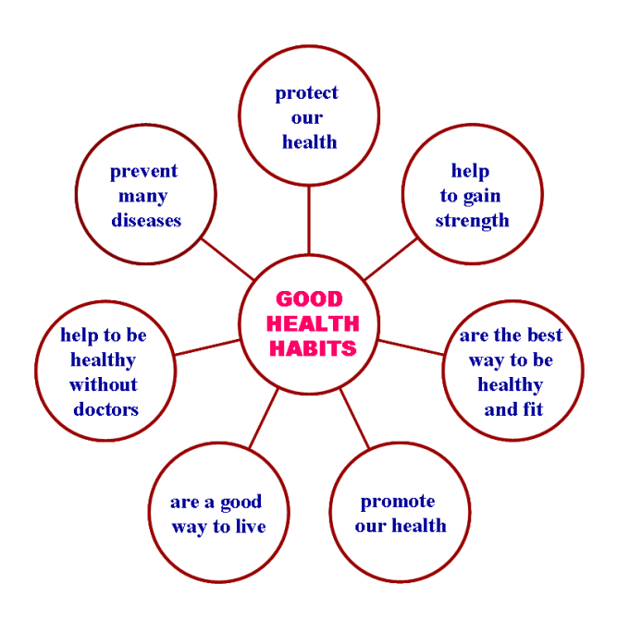And there is the scheme of effects of good habits on our health. Let’s read and translate these effects.

Another problem is bad habits. Can you name any bad habits (smoking, drinking alcohol, overeating, drug-taking, skip meals, physical inactivity, eating a lot of sweets, lack of sleep, eating between meals = snaking). What can we refer to this point? Write down please. Whowants?

Let’s read why bad habits are really harmful for us?

… can make you nervous/ unhealthy.  
…is bad for your health..  
… can lead to different  diseases.  
… can double the chance of dying.  
… can cause different health problems.

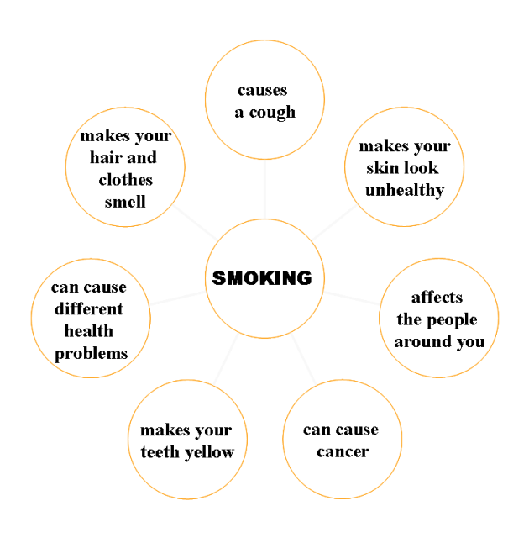In our modern life a lot of teenagers have bad habits. And the most popular are smoking and drinking. And I want to show you real effects of these bad habits. Let’s read and translate effects. (*просмотр слайдов с описаниями последствий употребления алкоголя и курения).*

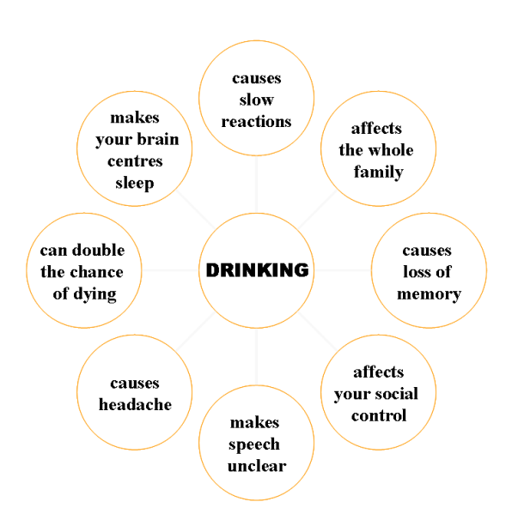

And tell me please what is more important for us: good health habits or bad health habits? Explain why? Of course, it is good health. And I believe that each of you understand these problems, which you can meet if you will have bad habits. I hope that you will never smoke and drink alcohol, because it is very harmful for you!

1. **РЕФЛЕКСИЯ**

Now let’s look at the black board. What have we done? We havebeen making the scheme of healthy way of life during the lesson with basic recommendations for preserving your health. Let’sarriveatconclusionsaboutit.

*(обучающиеся читают, что получилось на доске – в течение урока разработали схему «Здоровый образ жизни», переводят и делают выводы по теме)*

1. **ПОДВЕДЕНИЕИТОГОВУРОКА.**

What did we do at the lesson today? Do you like it? I see that you give a lot of useful information and I am very glad that you think about your health. I hope you will follow our advice and choose healthy food. I wish you good meal! And we present you with some general advice on healthy food, which will recall about your health (приложение 5).

**Список использованной литературы:**

1. Healthy Style of Life, N. Kudayeva//Английский язык (приложение к газете "Первое сентября") - 2010. - 48.
2. Keeping Fit//ELT News & Views - 2012. - April.
3. Millennium Sunrise//Speak Out (журнал для изучающих английский язык) - 2007. - 6.
4. To Smoke or not to Smoke?//Speak Out (журнал для изучающих английский язык) - 2010. - 1.
5. We Are What We Eat//Speak Out (журнал для изучающих английский язык) - 2009. – 1.
6. К. И. Кауфман, М. Ю. Кауфман, УМК «Счастливый английский.ру» / Happy English.ru – 2012. – 94-96.

**Приложение 1**

**CARD 1**

|  |  |  |
| --- | --- | --- |
| **surname** | **name** | **mark** |
|  |  |  |

|  |  |
| --- | --- |
| 1.The purse of the patient protracts  thedisease. | a) Здоровье дорожебогатства. |
| 2.Health is better than wealth. | b)Обжорство убивает быстрее,чем меч. |
| 3.Prevention is better than cure. | c)Голод-лучшая приправа. |
| 4.Hunger is the best sauce. | d)Мужчине столько лет,на сколько он себя чувствует,женщине-на сколько она выглядит. |
| 5.Gluttony kills more than the sword. | e)Болезнь легче предупредить,  чем лечить. |
| 6.A man is as old as he feels, a woman is as old as she looks. | f)Кошелёк клиента продлевает  болезнь. |

|  |  |  |  |  |  |
| --- | --- | --- | --- | --- | --- |
| **1** | **2** | **3** | **4** | **5** | **6** |
|  |  |  |  |  |  |

**Приложение 2**

|  |  |
| --- | --- |
| **point** | **mark** |
| 6 points | 5 |
| 5 points | 4 |
| 4 points | 3 |
| 1-3 points | 2 |

**Приложение 3**

|  |  |  |
| --- | --- | --- |
| Food help us to be + ADJ | It provides + NOUN | It needs to +V/ for… |

**Приложение 4**

|  |  |  |
| --- | --- | --- |
| Milk**refer to**  the dairy group | The dairy group**consists of** milk … | The dairy group**contains** milk … |

**Приложение 5**

|  |
| --- |
| **General Advice on Healthy Food**   1. Remember we are what we eat. Try to choose healthy food. Fruit and vegetables are ideal. 2. Never eat at night and avoid fat and sweet food as it causes obesity, which is a reason of heart diseases. 3. Never skip breakfast and never snack between meals. It will help you to avoid gaining weight. 4. Remember: bad habits are extremely dangerous for your health. 5. http://t0.gstatic.com/images?q=tbn:ANd9GcRQvZc7z3VaTDWQ0QTPJBRneFr0Kifh5AhDLg7s6nl4BBGcjSjWwbstT1oqSmoking causes lung cancer and it is easier to start to smoke than to give it up. 6. Taking drugs and alcohol destroys your mind and body. You will not notice how you will become an addict. 7. Do and play sports. It makes you strong and energetic. Keeping fit is very trendy today. 8. Have a regular lifestyle. Remember a proverb “Early to bed and early to rise makes a man healthy, wealthy and wise”. 9. Never use transport if it is possible to walk. 10. If you live in the city, have a rest out of it more often, as it is a brilliant opportunity to breathe fresh air. 11. Air your room before sleeping and don’t forget to do morning exercises. 12. Remember that losing health is easier than to restore it. Think about it now, till it is not too late! 13. And I wish you strong health for many years! |

|  |
| --- |
| **go to the skating-rink** |

|  |
| --- |
| **keep to**  **a diet** |

|  |
| --- |
| **eat a lot of vitamins** |

|  |
| --- |
| **stay active in day-to-day life** |

|  |
| --- |
| **go to the swimming pool** |

|  |
| --- |
| **do morning exercises every day** |

|  |
| --- |
| **go to bed early** |

|  |
| --- |
| **clean the teeth in the morning and in the evening** |

|  |
| --- |
| **walk in the forest** |

|  |
| --- |
| **wash hands before meal** |

|  |
| --- |
| **eat healthy food** |

|  |
| --- |
| **eat dairy products** |

|  |
| --- |
| **air rooms as often as possible** |

|  |  |
| --- | --- |
| **point** | **mark** |
| 5 points | 5 |
| 4 points | 4 |
| 3 points | 3 |
| 1-2 points | 2 |

**CARD 2**

**Group 1**

|  |  |  |
| --- | --- | --- |
| **surname** | **name** | **mark** |
| 1. |  |  |
| 2. |  |
| 3. |  |
| 4. |  |

Complete these healthy eating tips using **much, many, little, a lot of.**

|  |  |  |  |
| --- | --- | --- | --- |
|  | **sentence** | **answer** | **+** |
| 1. | Too ----- food makes you slim. |  |  |
| 2. | Too ----- food makes you fat. |  |  |
| 3. | Too ----- sweets are bad for you, especially for your teeth. |  |  |
| 4. | Eat ----- high fat food and ----- fibre. |  |  |
| 5. | ----- fruit and vegetables keep you healthy. |  |  |

**CARD 2**

**Group 2**

|  |  |  |
| --- | --- | --- |
| **surname** | **name** | **mark** |
| 1. |  |  |
| 2. |  |
| 3. |  |
| 4. |  |

Correct the mistakes using **less, more, little**:

|  |  |  |  |
| --- | --- | --- | --- |
|  | **sentence** | **answer** | **+** |
| 1. | Eatmoresugar. |  |  |
| 2. | Don'teatvegetables. |  |  |
| 3. | Eatmuchfat. |  |  |
| 4. | Eatlessfreshfruits. |  |  |
| 5. | Eat a lot of salt. |  |  |

**CARD 2**

**Group 3**

|  |  |  |
| --- | --- | --- |
| **surname** | **name** | **mark** |
| 1. |  |  |
| 2. |  |
| 3. |  |
| 4. |  |

|  |  |  |
| --- | --- | --- |
| **Russian sentences** | **English sentences** | **+** |
| 1. Ты съедаешь килограмм конфет в день. Это слишком много. |  |  |
| 2. Сколько овощей ты ел вчера? |  |  |
| 3. Если ты хочешь потерять вес, тебе следует кушать меньше сладкого. |  |  |
| 4. Сколько воды мы должны пить каждый день? |  |  |
| 5. Вам необходимо немного соли в день. |  |  |