Разработка урока по УМК «Английский язык»
9 класс. (Афанасьева О. В., Михеева И. В.)

Раздел 2: «People & Society».
Тема урока: «Make the most of your life» (Outstanding people)
Тип урока: систематизация знаний.
Цель урока: развитие коммуникативных навыков через работу по изучаемой лексикой теме.
Задачи урока:
Предметные: развивать лексические навыки по теме «Выдающиеся люди», активизировать речемыслительную деятельность по теме.
Личностные: способствовать развитию интеллектуальной, эмоциональной и мотивационной сферы личности учащихся; прививать интерес к изучению иностранного языка посредством использования ИКТ и темы урока;
Метапредметные: учить находить запрашиваемую информацию в языковом материале, осмысливать материал в русле задания, делать выводы; применять алгоритм условий задания.

Сценарий урока
Good morning, Students. I’m Natalia Yurievna. Today I’m your English teacher. I hope we’ll enjoy working together. Ready to cooperate? So let’s start by looking at these people…
- Разминка. Активизация речевых навыков. Настрой на урок.
[фото лауреатов нобелевской паремии]

- What do you know about them?
- What do they have in common?
- Why do they deserve our admiration?
<ответы учащихся основаны на пройденном материале>

You are perfectly right. They did their great share to make the world a better place.

- Определение темы урока.
- So can you identify what we are going to speak about today?
<outstanding people, the Nobel prize winners>
- Yes, we’re going to speak about the Great People who made a Great contribution to the life of the society.
But as I see we didn’t say anything about this young girl, who is among all these Great Names. Who is she? What special has she done? This is the intrigue of our lesson…

- Активизация лексики урока.
Before we find out, let’s revise some words & phrases which will be useful for the lesson.
<повторение слов и выражений с помощью платформы Quizzlet
https://quizlet.com/_7la4eh?x=1qqt&i=2egm4y >

I hope you enjoyed this activity! You see, this platform enables you to learn the words quickly and effectively. There are a lot of options there. I suggest you using this platform and create your own modules here
- Работа по видео.
Most these phrases are from the trailer to the film about the Youngest Nobel Prize Winner in history – Malala Yuuzufzai. While watching it, try to notice her arguments for the things she considers important.
Работа на сайте British Council: https://learnenglishteens.britishcouncil.org/study-break/video-zone/he-named-me-malala

- Ответы на вопросы по теме урока (задание формата ОГЭ).
Just imagine: this girl puts her life at risk and she continues to fight for the girls right to education. Luckily, the right to education is essential in our country. Do you value this right? Let’s take part in an imaginary survey.
Распределение ролей между двумя участниками. Ответы учащихся записываются на диктофон для последующего комментирования в рамках критериев оценивания устной части ОГЭ.

Задания для социологического опроса:
Hello! I am an assistant of the Human Rights Organization. We kindly ask you to take part in our survey. We need to find out how teenagers feel about the right for education in our region. Please answer the six questions. The survey in anonymous - you don’t have to give your name. So let’s get started.

Question 1: How old are you?
_________________________________________________________________
Question 2: What class are you in?
_________________________________________________________________
Question 3: How many lessons a day do you have? _________________________________________________________________
Question 4: Would you like to have less classes at school? Why? Why not?
_________________________________________________________________
Question 5: If you had less classes at school, what would you use this free time for?
_________________________________________________________________
Question 6: Is the knowledge you get at school useful for your future career plans?
_________________________________________________________________
That’s the end of the survey. Thank you very much for cooperation.

Hello! I am an assistant of the Human Rights Organization. We kindly ask you to take part in our survey. We need to find out how teenagers feel about the right for education in our region. Please answer the six questions. The survey in anonymous - you don’t have to give your name. So let’s get started.

Question 1: How old are you?
_________________________________________________________________
Question 2: What class are you in?
_________________________________________________________________
Question 3: Are you satisfied with the range of subjects at school?
_________________________________________________________________
Question 4: Should all subjects be compulsory at school? Why? Why not?
_________________________________________________________________
Question 5: What subjects should be optional in your point of view? Why?
_________________________________________________________________
Question 6: What is the value of school education for you?
_________________________________________________________________
That’s the end of the survey. Thank you very much for cooperation.

- Монологическое высказывание (задание формата ОГЭ).
I see that understand the value of education. And thanks to such outstanding People as Malala more and more children will benefit from this basic human right. I admire this person. Do you have people you admire? May be they are ordinary people but they encourage you in life. Give a talk about them using the following plan.
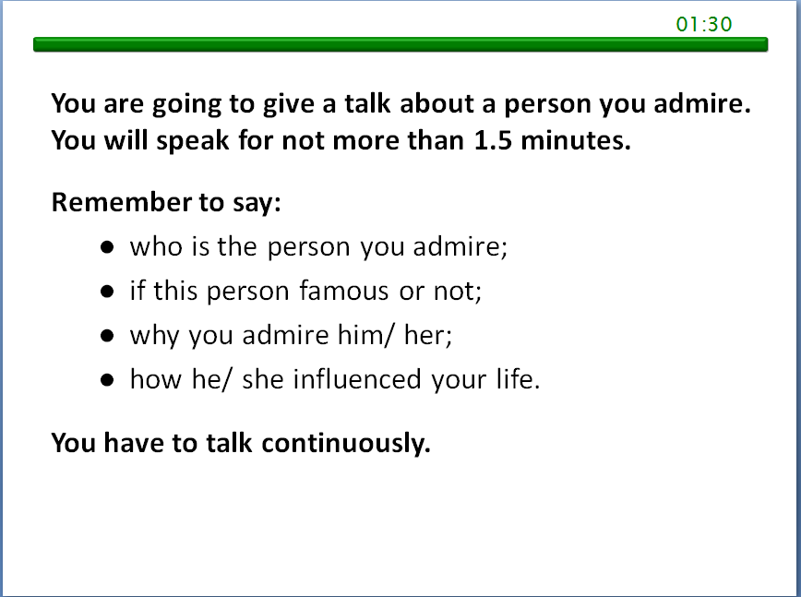 | 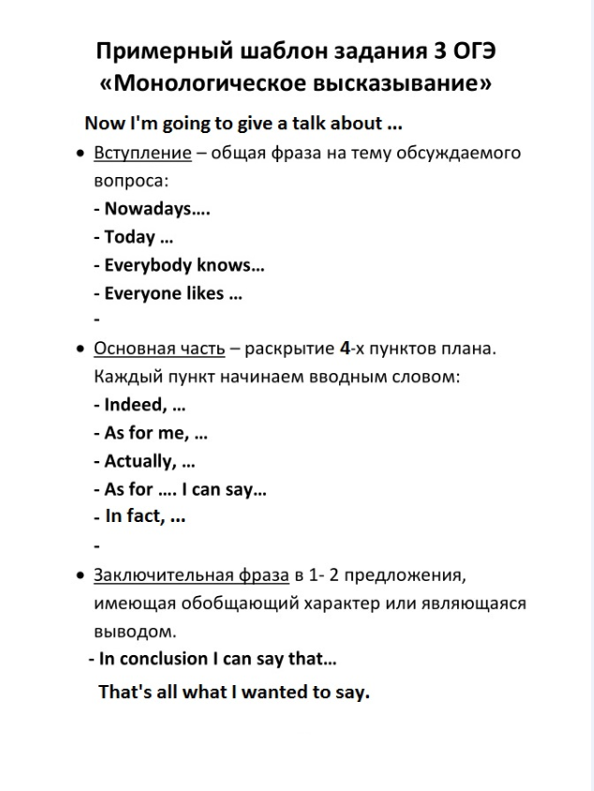

Образцы монологов для обсуждения с учетом критериев оценивания Устной части ОГЭ по иностранному языку:
1) https://yadi.sk/d/BqR-UUSxnJq5aA
2) https://yadi.sk/d/CV4110oaOdANSw

Заслушиваются ответы учащихся. Время выполнение задания засекается по школе времени на презентации.

- Подведение итогов урока. Рефлексия.
I’m really happy that you have decent role-models in your life, who encourage you to get the most of your life now. this is Malala’s motto. People appreciate her. They leave a lot of positive comments under the video. Imagine, you met this daring girl in person – what would you say to her?
It’s a real pleasure to hear such warm words. they show that you understand the really important things in life.
Thanks a lot for the cooperation, for your hard work and your warm smiles. Take a small calendars – here is a link to my VK group with lots of exam tasks and useful material for you: https://vk.com/englishpuffin

Список используемой литературы:

- Английский язык. 9 класс. Учебник. Афанасьева О. В., Михеева И. В.
- Ресурс сайта British Council: https://learnenglishteens.britishcouncil.org/study-break/video-zone/he-named-me-malala
- Ресурсы сайта Cambridge Dictionary: https://dictionary.cambridge.org/ru/
- Ресурсы сайта ФИПИ: http://fipi.ru/oge-i-gve-9/demoversii-specifikacii-kodifikatory

Macmillan Exam Skills for Russia: Учебное пособие для подготовки к ОГЭ по английскому языку: говорение.
- ОГЭ. Английский язык: типовые экзаменационные варианты: 20 ваинатов/ под ред. Н.Н.Турбаневой. – М.: Издательство «Национальное образование», 2020. – 288с.

