Lesson Plan
Lesson Focus:
Predictive, productive skills (Listening/Speaking)
Hobbies
Hobby, kinds of hobbies
Students:
11-12 years, middle level, 6 grades, for students with middle and high middle abilities.
Students will remember kinds of hobbies; speak about their (partners/friends/ members of the family0 hobbies. Students will practice hobby vocabulary.
(Age, Level, Grade, Assumed knowledge)
Materials:
List with the names of hobbies
Picture the some kind of hobbies
Texts for listening

Anticipated Problems & Solutions:
Attention should be paid to grading language accordingly and providing example so that the students can understand the task.
SS may spend too much time doing the tasks, to prevent it the teacher should give a short time limit and stick to it.
SS may have little ideas on what to say in this activity. Teacher should provide prompts and demonstration and also pay close attention during monitoring and offer support to students struggling with ideas

Time | Stage, Aims | Procedure | Interaction
5min | Lead-in  To introduce the them “hobby” and involve the SS | T tells the students how she spends her free time.  Asks the students how they spend their free time (discuss in pairs) | T-SS, S-S
5 min. | Orientation  SS are preparing to listen to the text | Using “Hobbies Vocabulary” answer some questions.  T tells SS that they are going to listen to some texts where some students tell about their hobbies. | (work in groups)  T-SS, S-S
5  min | Gist task | Listen to the texts and fill in. Discuss in groups. Exchange your answers with other groups. | (work in groups)  S-S
5  min | Specific information task(True/False) | Listen to the texts again and do the task “True or False”. Exchange your answers with other groups. | work in groups)  S-S
6  min | Detail task | Listen to the texts again and complete the table. Exchange your answers with other groups.  Divide in groups and the next tasks:  Group 1 – fill in “Age”  Group 2- fill in “Place”  Group 3 – fill in “Activity’ | work in groups)  S-S
13  min | Follow up | SS have freer practice talking about their (partners/friends/members of the family) hobbies, teen’s popularhobbies. SS tell about hobbies of members of their groups | work in groups)  S-S
1 min | Reflection | What I like about this lesson?  What I have known new?  What I don’t like about this lesson? | T-SS, S-S

1. Hobbies Vocabulary Word List
A) Activities, Angling, Antique collecting, Aquariums, Art, Artifacts, Avocation
B) Backpacking, Ballooning, Biking, Bingo, Bird-watching, Board games, Boating, Bridge
C) Camping, Cards, Carpentry, Carving, Ceramics, Classes, Coin collecting, Collectibles, Collection, Cooking, Crafts, Crewel, Crochet, Crossword puzzles
D) Dancing, Dealer, Decoupage, Delight
E) Embroidery, Enjoy, Enrichment, Entertainment, Expertise
F) Fishing, Free time
G) Gambling, Games, Gardening
H) Handicrafts, Hiking, Hunting
I) Ice-skating, Ikebana, Interests
J) Jogging, Joy
K) Kite flying, Knitting
L) Leisure, Linger, Loiter
M) Macrame, Magic, Model airplanes, Model cars, Model trains, Models, Mountaineering
N) Needlepoint, Numismatics
O) Obsession, Origami
P) Painting, Passion, Pastime, Philately, Photography, Playing cards, Pleasure, Possession, Pottery making, Puppetry, Purchases, Puzzles
Q) Quilting
R) Reading, Relaxation, Retirement, Riding, Rock climbing, Rug hooking
S) Sales, Scrimshaw, Scuba diving, Sewing, Sharing, Shells, Shopping, Skeet shooting, Skill, Skydiving, Snorkeling, Spelunking, Sports, Stamp collections, Stitch, Surfing
T) Time, Trinkets
U)
V)
W) Weaving, Whittling, Woodworking
X)
Y) Yachting
Z)

Hobbies for teenagers
Music (singing, composing)
Dancing
Poetry
Watching movies
Computer games or programming
Social Networking
Adventure or extreme sports
Fitness or working out in a gym
Car or bike racing

See more at: http://www.myvocabulary.com/word-list/hobbies-vocabulary/#sthash.Q9H6ltJp.dpuf
Conversation Questions
Hobbies
- Do you have a hobby?
- What are your hobbies?
- How long have you had your hobby?
- What hobbies are the most expensive?
- What hobbies are the cheapest?
- What hobbies cost nothing at all?
- What hobbies are the most popular in your country?
- Is hunting a hobby or a sport in your country?
- What hobbies are the most popular with women in your country?
- What hobbies are the most popular with men in your country?
- Did you have any hobbies when you were a child?
- Can you think of any hobbies which are popular with children and adults?
- Do you think a hobby is different from a sport?
- Are there any hobbies you would like to try?
- Are there any dangerous hobbies?
- Are there any hobbies you can do in other countries, but not your own?
- What hobbies do you think are the most difficult?
- Do you know any unusual hobbies?
- What hobbies do your friends have?
- Is it really important to have a hobby?
Compiled by Tatyana Makhrina

Addendum 1
2. Listen to the texts and fill in:
Hi! My name is Tom.  I'm twelve years old.  I live in Madrid.  I like doing karate after school. It’s fun.  I learn how to fight and defend myself.  In the summer vacation, I go with the kids from my karate club to a cerate camp. We learn karate and have fun together.  Every year there is a karate competition in Madrid.  Last year I went to the competition and won a gold medal.  The only problem with karate is that you work hard and  you are tired! I don't want to be tired! | Hi! My name is Maria.  I'm eleven years old.  I come from Rome. I draw pictures.  I draw all the time.  I draw thing for my friends: greeting cards and posters.  Sometimes I draw in class, but my teacher doesn't want me to draw. She wants me to listen to her. So I have a problem. But I love art lessons!  Last week I went to the art museum and saw some famous pictures. It was great!  Drawing is fun.  It's easy: you need paper and pencils.
Hi! I'm Roberto.  I'm eleven years old. I come from Brazil.  I don't like sport very much, and I'm not very good at it.  I like music. My hobby is playing the guitar.  Sometimes I play at concerts with other kids.  The only problem that my big brother plays the guitar too,  and there is only one guitar in the house.  He doesn't want me to give the guitar.  He wants it all the time! It's a problem!  Last month a famous rock singer came to Brazil, and I went to the concert with my brother.  It was cool! | Hi! My name is Rita.  I'm twelve years old and I live in Israel.  I love dancing. It's my favorite hobby.  I don't like ballet, but I like salsa. I go to salsa lessons after school. The teacher is really good!  At the end of the year, we had a salsa show. We had a lot of fun, and everyone said we were very good. We made a lot of money from the tickets.  The money is to help sick children.  Dancing takes lots of time.  Sometimes I don't have time for my homework.  And I want to watch television, but I don't have time.  That’s my biggest problem.

 | 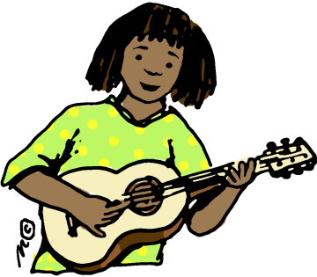 | 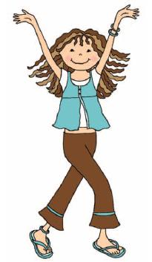 | 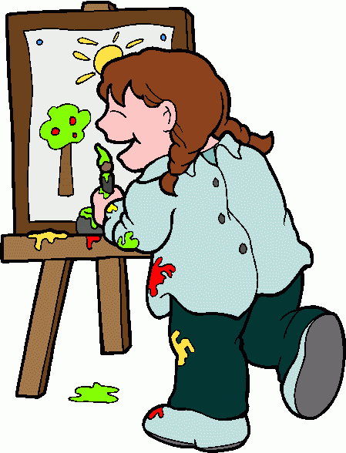
My name is _____________  My hobby is _____________  My country is _____________ | My name is _____________  My hobby is _____________  My country is _____________ | My name is _____________  My hobby is _____________  My country is _____________ | My name is _____________  My hobby is _____________  My country is _____________

- True or False?

1.Tom works hard. 9. Maria speaks Italian.
2.Rita doesn't like salsa. 10.Tom has a camp in the winter.
3.Maria is twelve years old. 11.Mari doesn't have any problems.
4.Tom won a silver medal. 12.Roberto likes television.
5.Roberto lives in Brazil. 13.Tom thinks karate is fun.
6.Maria was in the museum. 14.The concert wasn't cool.
7.Rita has a bad teacher. 15.Roberto's hobby is sport.
8.Roberto has two brothers. 16.Maria danced in a show.

- Complete the table.

 | Age | Place | Activity | Good Things | Problems
Tom
Rita
Maria
Roberto

Source^ http://www.englishexercises.org

