Lesson Specification Report (LSR) Lesson Plan Back-to- School activities
Lesson Name- Goal Setting (How to teach senior students to set goals)
Target students- grades 11- 12
Objective 1: To encourage students to set and reach their goals
Objective 2: Students will be able to give examples of goals and define their own formula for success
Objective 3: Students will be able to write essays on the importance of setting goals what parable is
Skills tested: speaking, writing,
Language Focus- the students will be able to
- Define parables
- Give examples of parables
- Write their own parable
Materials Used- visual aids, A4 format, worksheets

Procedure

Activity 1 Warm Up
Ask your students the following questions before starting the lesson and discussion:
  - Does anyone know what a parable is?
  - Can anyone briefly share an example of a parable?

Activity 2 Reading Comprehension
Text 1 A Formula for Success
There is an old parable about setting goals and planning.
Once upon a time a man pleaded a piece of land from a tribe chief. The chief gave the man a pole and told him that if he could insert the pole in a place which he could come back before the sunset, the land between tribe station and the pole would belong to him. The man was so greedy that he exhausted to death on the way back. From this story we can see that although the man had his goal and action, he had no plan. A good plan is essential for success. It can quantify the task and make it possible for a man to arrange his time effectively.
First, my means of planning a man quantifies his task. He divides his final target into several periodic ones. Thus, he could average the pressure and see his progress during each period. A good plan encourages a man to fulfil his destination positively rather than passively. Actually all successful people have their careful plans. If one could execute his periodic target successfully every time, he could easily achieve his ultimate target. Moreover, during this process a man will acquire a lot of qualities that are essential to success.
Secondly, the advantage of good planning is that one can dispose his time and energy more effectively. It occurs very often in life that one should do a lot of things simultaneously. To take care of his children, to spend enough time with his family and friends, only by careful planning can a man accomplish his several targets in a short time.
Let us come back to the former story. If the man were a coward he would always fear, that he could not come back before the sunset. The answer must be that he got much less than he could have as he couldn’t predict some difficulties that might appear on his way.
Chance can sometimes help a man to succeed; nevertheless, it always favours a prepared mind.

After-reading activities
- Class discussion
- The Use of Graphic Organizers
Encourage students to use graphic organizers (charts or concept "maps") to help them visualize concepts and key relationships between ideas from their readings. These should be started right after students have completed a reading, whereas revisions and additions can be done after class discussions.
It's a good idea to show students several examples of graphic organizers and explain which ones work well with different text patterns. Many reading skills texts have examples of various graphic organizers with explanations of how they might best be used. Here is an example of one type of graphic organizer for comparing different concepts:
Student Worksheet -----------------------------------------------------------
 | Formula For Success | agree | disagree
1 | 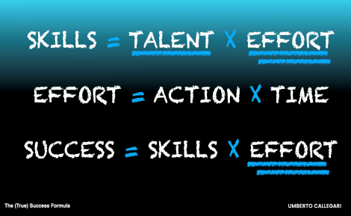
2 | 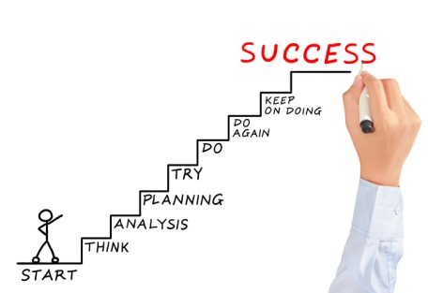
3 | 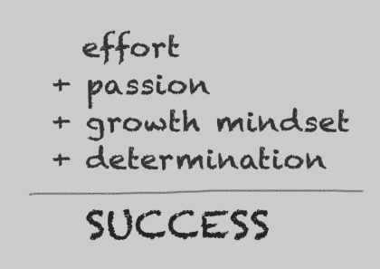
4 | 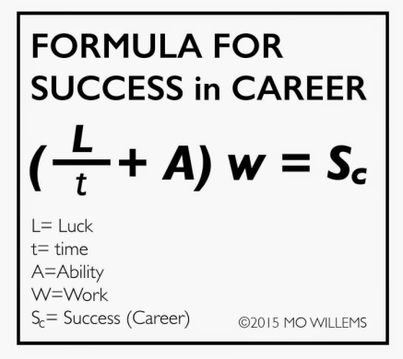

Teacher Worksheet ----------------------------------------------------------
- The Hook
Teachers often complain about unmotivated learners. The hook changes that. The hook tells students why they need something, what its purpose is, or intrigues them to listen for more. It can be short and sweet, even one sentence. “Who wants to be successful?”
- The Story or Parable
People love stories and stories help us to remember. Stories help us to relate to something, to attach meaning, and to see the relevance. Stories draw us in and make us want more. Parable is a simple story used to illustrate a moral or spiritual lesson- (Reading Comprehension -Text 1)
Parable-synonyms: fable, lesson, moral tale, moral story, allegory
3 Make your Formula of Success
Goals -______________-______________-____________= success
Goals-Actions-Skills-Plans-Efforts-Personality traits---X----X= Success
(Necessary conditions, sufficient, insufficient)

- Do you agree with this formula for success?
- Offer your own variant
Reading resources -Why are Goals Important?
When you set a goal you want to achieve, you know that you want it so you put effort into achieving it – the will power helps you to be diligent, focused and averting distractions. Hence, focus helps to avert any impedance to your goals that may be caused by distractions.
achieving anything requires certain sacrifices to be made and certain challenges to be overcome. It requires us to be confident enough to make sacrifices and overcome the challenges that try to deter us.
When setting goals, you need to evaluate many aspects of your life and your goals. This trait both increases your knowledge and experience which in turn make you wiser.
Like Earl Nightingale said: "All you need is the plan, the road map, and the courage to press on to your destination."

"Teach Me the Art of Small Steps" A Prayer by Antoine de Saint-Exupery
Few know that Antoine de Saint-Exupery wrote this prayer in a very difficult life situation and it helped him to get strength and faith. Keep it to remember the main things in the world!
“Lord, I ask not about miracles, and not the mirages, and the strength of each day.
Teach me the art of small steps.
Make me an observant and resourceful, that the diversity of everyday life in time to stop
on discoveries and experiences that made me excited.
Teach me how to properly dispose of time in my life.
Give me a subtle flair to distinguish primary from the secondary.
I ask about the power of restraint and measures that I have on life fluttered and slid,
and intelligently planned throughout the day, could see the tops and gave,
and at least sometimes would find time to enjoy art.
Help me to understand that dreams can not be a help. No dreams of the past or dreams of the future.
Help me to be here and now and accept that moment as the most important.
Protect me from a naive belief that everything in life should be smooth.
Give me a clear consciousness that the complexity of defeat, the fall and failure
are just a natural part of life, through which we grow and zreem.
Remind me that the heart is often argues with reason.
Send me the right time for someone who has the courage to tell me the truth, but tell her loving!
I know that many problems can be solved if we do nothing, so teach me patience.
You know how much we need the friendship.
Let me be worthy of the most beautiful and tender gift of Yours.
Give me a rich imagination to the right time, at the right time, right place,
silent or speaking, give someone the necessary heat.
Do me as a man who knows how to reach those who really “down”.
Protect me from fear to miss something in life.
Let me not what I myself wish, but what I really need. Teach me the art of small steps

Idioms about ‘Success’

- It’ll be all right on the night---up to standard or good enough whe you are tested on sth
- You’ve got nothing to lose---you should take a risk because things can’t get any worse
- The sky’s the limit---you can achieve anything
- Fingers crossed--good luck
- High-flier---sb who has the potential to do very well in education or business
- Hungry for success----sb who is ambitious
- Stop at nothing---will do anything for success
- Pull your socks up---make an effort to improve your behaviour or work because it is not good enough
- Set your sights on sth----to decide to do sth successfully
- Don’t get left behind---Pull out all the stops – do everything you possibly can to achieve sth
- Sow the seeds for success----do things/actions that are known to be positive and will help you
- There’s light at the end of the tunnel---positive feeling because you are near the end of a difficult period or job

AMBITION - DETERMINATION
- at all costs
  - If you are determined to obtain or achieve something at all costs, you want it regardless of the expense, effort or sacrifice involved.
"The journalist was determined at all costs to get a report from the war zone."

stand your ground
- If you stand your ground you maintain your position and refuse to yield or give way.
"He claimed innocence and stood his ground in spite of the repeated accusations."

- blood, sweat and tears
  - A project or action which involves blood, sweat and tears requires a lot of effort and hard work.
"His success wasn't due to luck; it was blood, sweat and tears all the way."
- have something on the brain
  - If you have something on the brain, you think or talk bout it all constantly.
"He never stops talking about golf. He has golf on the brain!"
- dig in your heels
  - If you dig in your heels, you refuse to do something, especially if someone is trying to convince you to do so.
"My grandfather dug in his heels and refused to move to an apartment."
- explore all avenues
  - If you explore all avenues, you try out every possibility in order to obtain a result or find a solution.
"We can't say it's impossible until we've explored all avenues."
- fight tooth and nail
  - If you fight tooth and nail for something, you fight with energy and determination.
"The Transport Minister fought tooth and nail to have the proposed road safety law accepted."
- go the extra mile
  - If you go the extra mile, you do more than what is expected of you.
"You can count on Tom; he's always willing to go the extra mile."
- go into overdrive
  - If someone or something goes into overdrive, they begin to work very hard or start to perform intensely
"At the start of every new collection my imagination goes into overdrive."
- going places
  - To say that someone is going places means that they show talent and ability that will no doubt lead to a successful future.
"Even at college it was obvious that Paul was going places."
- keep your nose to the grindstone
  - A person who keeps their nose to the grindstone is someone who concentrates on working or studying hard.
"Emma was so determined to get into the college of her choice that she kept her nose to the grindstone all year."

- hang in there
  - This expression is used to encourage someone to persevere and not give up in spite of the difficult circumstances.
"I know the atmosphere is very tense, but just hang in there and things will eventually calm down."
- hang on by the fingernails
  - When you hang on by the fingernails, you succeed in continuing to do something in a very difficult situation.
"The restaurant is losing more and more customers; the owner is just hanging on by his fingernails."
- have your heart set on something
  - Someone who has their heart set on something is determined to obtain something they want very much.
"From an early age Tiger had his heart set on becoming a professional golfer."

