SCHOOL OF ROCK WORKSHIT
PRE-WATCHINGACTIVITIES
- Discuss the following using the phrases:
What is school (college) for you?
As for me school is ______________________________________________________________
Firstly_________________________________________________________________________
Secondly ______________________________________________________________________
Thirdly________________________________________________________________________

What subjects would you like to have at school (college)?
I would like to have ______________________ at school because ______________________________________________________________________________
During these lessons we would _____________________________________________________
If we had such a lesson at school I would______________________________________________

What is your ideal teacher? Why?
The ideal teacher is a person who\whom\whose ____________________________________________________________________________________________________________________________________________________________
I think that ____________________________________________________________________________________________________________________________________________________________
The teacher is considered to be ____________________________________________________________________________________________________________________________________________________________

What skills should have a person to be a good teacher?
To be a good teacher a person should have ____________________________________________________________________________________________________________________________________________________________
I should say that ____________________________________________________________________________________________________________________________________________________________
In conclusion ____________________________________________________________________________________________________________________________________________________________

- Find the translation of the following words
to catch (caught, caught)____________________________________________________________
lame____________________________________________________________________________
freeloader________________________________________________________________________
dysfunction______________________________________________________________________
to push smb around________________________________________________________________
to share the rent___________________________________________________________________
to be about to hit a big time _________________________________________________________
to be on _________________________________________________________________________
contribute_______________________________________________________________________
temp____________________________________________________________________________
substitute teacher__________________________________________________________________
to liberate________________________________________________________________________
mooching of______________________________________________________________________
to be fired________________________________________________________________________
awesome_________________________________________________________________________
to vote___________________________________________________________________________
embarrassment____________________________________________________________________
read between the lines______________________________________________________________
to be a nut________________________________________________________________________
gig_____________________________________________________________________________
to pay upfront_____________________________________________________________________
tax______________________________________________________________________________
corporal punishment________________________________________________________________
verbal abuse_______________________________________________________________________
to be on best behavior_______________________________________________________________
hangover_________________________________________________________________________
chill_____________________________________________________________________________
crapola___________________________________________________________________________
schedule_________________________________________________________________________
have runs_________________________________________________________________________
time for recess_____________________________________________________________________
demerits__________________________________________________________________________
to be in charge_____________________________________________________________________
conscientious_____________________________________________________________________
hug______________________________________________________________________________
flip-flop__________________________________________________________________________
working stiff______________________________________________________________________
gotsmb brainwashed________________________________________________________________
rock out__________________________________________________________________________
delusional________________________________________________________________________
to waste the time___________________________________________________________________
guitar pick________________________________________________________________________
plug with_________________________________________________________________________
keyboards________________________________________________________________________
cello____________________________________________________________________________
percussion_______________________________________________________________________
mess around______________________________________________________________________
stoked to slack off _________________________________________________________________
to compete_______________________________________________________________________
keep it zipped_____________________________________________________________________
back up singers____________________________________________________________________
cat’s pajamas______________________________________________________________________
bee’s knees_______________________________________________________________________
groupie___________________________________________________________________________
room parent_______________________________________________________________________
ring the bell_______________________________________________________________________
catchy___________________________________________________________________________
goof off__________________________________________________________________________
roadie____________________________________________________________________________
to break the rules___________________________________________________________________

- Make 5 sentences using the words
- ____________________________________________________________________________________________________________________________________________________________
- ____________________________________________________________________________________________________________________________________________________________
- ____________________________________________________________________________________________________________________________________________________________
- ____________________________________________________________________________________________________________________________________________________________
- ____________________________________________________________________________________________________________________________________________________________

THE PLOT
School of Rock, also called The School of Rock, is a 2003 American comedy film directed by Richard Linklater, written by Mike White, and starring Jack Black. The main plot follows struggling rock singer and guitarist, Dewey Finn (Black), who is kicked out of his band and subsequently disguises himself as a substitute teacher at a prestigious prep school. After witnessing the musical talent in his students, Dewey forms a band of fourth-graders to attempt to win the upcoming Battle of the Bands and pay off his rent. The picture's supporting cast includes White, Joan Cusack, Sarah Silverman and Miranda Cosgrove.
School of Rock received highly positive reviews from critics and went on to gross over $131 million worldwide. At the time, it was the highest grossing musical comedy of all time, until it was overtaken in 2015 by Pitch Perfect 2.A stage musical adaptation opened on Broadway in December 2015, and a television adaptation for Nickelodeon is also due to premiere in 2016.

CAST
- Jack Black as Dewey Finn (lead singer, guitar)
- Joan Cusack as Principal Rosalie "Roz" Mullins
- MikeWhite asNedSchneebly
- Sarah Silverman as Patty Di Marco
- Miranda Cosgrove as Summer "Tinkerbell" Hathaway (band manager)
- Joey Gaydos Jr. as Zack "Zack-Attack" Mooneyham (lead guitar)
- Kevin Clark as Freddy "Spazzy McGee" Jones (drums)
- Rebecca Brown as Katie "Posh Spice" (bass)
- Robert Tsai as Lawrence "Mr. Cool" (keyboards)
- Maryam Hassan as Tomika "Turkey Sub" (second voice, lead choir)
- Caitlin Hale as Marta "Blondie" (choir)
- Aleisha Allen as Alicia "Brace Face" (choir)
- Brian Falduto as Billy "Fancy Pants" (stylist)
- Zachary Infante as Gordon "Roadrunner" (assistant, lights)
- James Hosey as Marco "Carrot Top" (assistant, special effects)
- Angelo Massagli as Frankie "Tough Guy" (security)
- Cole Hawkins as Leonard "Short Stop" (security)
- Jordan-Claire Green as Michelle (groupie)
- Veronica Afflerbach as Eleni (groupie)
- AdamPascal asTheo
- LucasBabin asSpider
- LucasPapaeliasasNeil
- ShawnRodneyasShawn

WHILE WATCHING ACTIVITIES

- Finish the dialogue
- What’s up?
- I don’t think I can __________
- What are you talking about. Come here.
- So, Tomika, what’s _____________________________. What do you mean you ____________________.
- I don’t feel good. _____________________________
- Just let Alicia and Martha to do it.
- No.
- They can’t _________________. I need you. What is it? Are you ___________________?
Yeah, why. What are you _____________________________?
- They are gonna laugh at me.

- Match the reply and the speaker
Patty Di Marco | Ok, Teach, teach, teach. All right, look, here’s the deal. I’ve got a hangover. Who knows what that means.
"Zack-Attack" Mooneyham (lead guitar) | I’ll make up some samples.
"Spazzy McGee" Jones (drums) | Mr.S? We came up with some names for the band.
Billy | Want a piece of me?
"Fancy Pants" | Come on, I may never have another girlfriend. I mean just come on, Come up with some money, please.
DeweyMichelle(groupie) | He is a freeloader, it’s time for all this dysfunction to stop.
Ned Schneebly | Ok, but I’m not much of a singer.

AFTER WATCHING ACTIVITIES

- Describe the moment at the picture
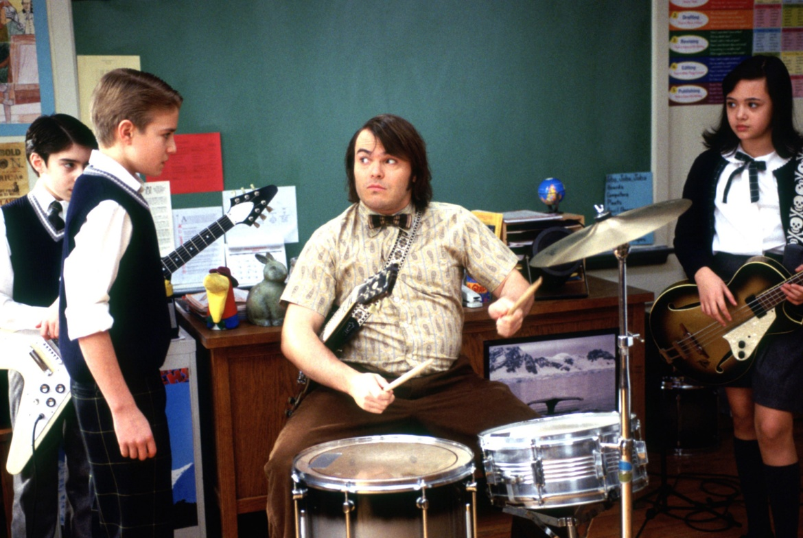

_____________________________________________________________________________________________________________________________________________________________________________________________________________________________________________________________________________________________________________________________________________________________________________________________________________________

________________________________________________________________________________________________________________________________________________________________________________________________________________________________________________________________________________________________________________________
- Prepare a short topic “If I were a teacher”
If I were a teacher I would …
_________________________________________________________________________________________________________________________________________________________________________________________________________________________________________________________________________________________________________________________________________________________________________________________________________________________________________________________________________________________________________________________________________________________________________________________________________________________________________________________________________________________________________________________________________________________________________________________________________________________________________________________________________________________________________________________________________________________________________________________________________________________________________________________________________________________________________________________________________________________________________________________________________________________________________________________________________________________________________________________________________________________________________________________________________________________________

